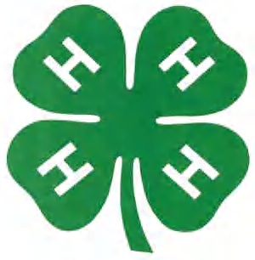

San Juan County 4-H Report Form
August 2024 Updated Form

To be typed by the 4-Her (Novice and Cloverbuds may handwrite).
I am a Novice Junior Senior 4-H Member
Current 4-H Year: 20 to 20
Name: | Date of Birth:
Club: | Years in 4-H:
Home Address:
City, State, Zip:
Name of School: | Grade:
Number of Club Meetings held this year:
Number of Club Meetings you attended: In Person_______ On-line _______

STATEMENT BY 4-H MEMBER

I have personally prepared this report and certify that it accurately reflects my 4-H work.

Date: _____________ Signature of 4-Her: __________________________________________

APPROVAL OF THIS REPORT

Date: ____________ Signature of Parent or Guardian: ___________________________

Date: _____________ Signature of 4-H Club Leader: ______________________________
Fill out this form as completely as possible. Designate your level of participation with the appropriate letter or letters as shown below:

************************************************************

PROJECTS TAKEN THIS 4-H YEAR:

“√” 4-H Project Name (Place an “√” next to the projects that will be judged in this record book)

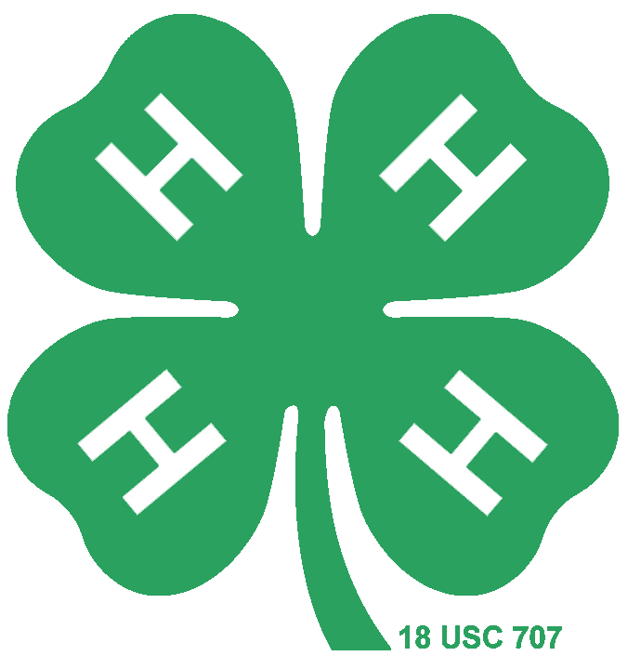

Directions: For each area list activities/awards that apply. In some cases, one activity may fall into multiple categories. You may list them in more than one category. If you do not have anything that applies in the category do NOT leave it blank. Enter “N/A” or “none”. This indicates that you have completed the form and simply do not have anything that applies to that category. You are welcome to add additional pages for any category, however, note that, so the judges know to look for additional pages. These pages, along with your 4-H Story, are the base score for all awards. Novices are welcome to hand write forms. Please read EACH CATEGORY DISCRIPTION! We ask Jr. and Sr. members to type forms. All activities from Oct. 2022-Oct. 2023 qualify.

DEMONSTRATIONS/ ILLUSTRATED TALKS/ PUBLIC SPEAKING

List all demonstrations and illustrated tells you have given this year related to 4-H. Include where they were presented and how many times. List all public speaking opportunities you have experienced this year related to 4-H. Include 4-H presentations on radio, TV, and school or other locations. You may also include public speaking contests.

Title Where # of Times

4-H LEADERSHIP

List your 4-H leadership experiences in helping others plan programs, lead discussions, prepare demonstrations, and project work or other 4-H activities. Indicate the level - Local Club (L), County (C), District (D), State (S), and/or National (N).

4-H Leadership Experience Where Level
4-H EXHIBITS, SHOWS, FAIRS, TOURS, AND CAMPS, SCHOOLS, WORKSHOPS, ETC.

List 4-H activities you participated in this year. Include where the activity took place and the level --- Local Club (L), County (C), District (D), State (S), and/or National (N).

4-H Activity Where Level

4-H OFFICES AND COMMITTEES

List the 4-H office(s) you held and committees you served on this year. Indicate the level ----- Local Club (L), County (C), District (D), State (S), and/or National (N).

4-H Office or Committee Level

4-H CONTESTS, JUDGING, ETC NOT AT FAIRS.

List all 4-H contests you participated in this year. List type of contest and where contest was held. This can include personal participation contests, club spirit contests, “just for fun contests” (costume contest etc.) Indicate the level - Local Club (L), County (C), District (D), State (S), and/or National (N).
(May list public speaking contests in this section too)

Contest Where Level

4-H CITIZENSHIP / COMMUNITY SERVICE LEARNING

List your individual or group 4-H citizenship and/or community service experiences this 4-H year. Indicate the type of service- Direct (D) Youth doing hands on service while interacting with the community they are serving. Indirect (I) Youth participated in food/ clothing/ supply drives, youth made cards, care packages etc. However, do not come in contact with the community they are serving. Advocate (A) Youth raise awareness and/or funds for community needs. Examples: Advocate for All Abilities Part, Fun Run for Cancer Research, Start a Summer Reading Club.

Type of Service Type
4-H AWARDS AND RECOGNITION:

List the most important 4-H awards you received for your project work, contests, 4-H scholarships, and other recognition. Include: ribbons received, honors, trips earned, and recognition received. Indicate the level - Local Club (L), County (C), District (D), State (S), and/or National (N). (Use additional pages, if needed) 1st though 5th place may be recorded for local, county, district and state. All placings for national awards may be recorded. Team awards may be recorded.

Type of Award Received for Level

