200.A-6 (R-2006)

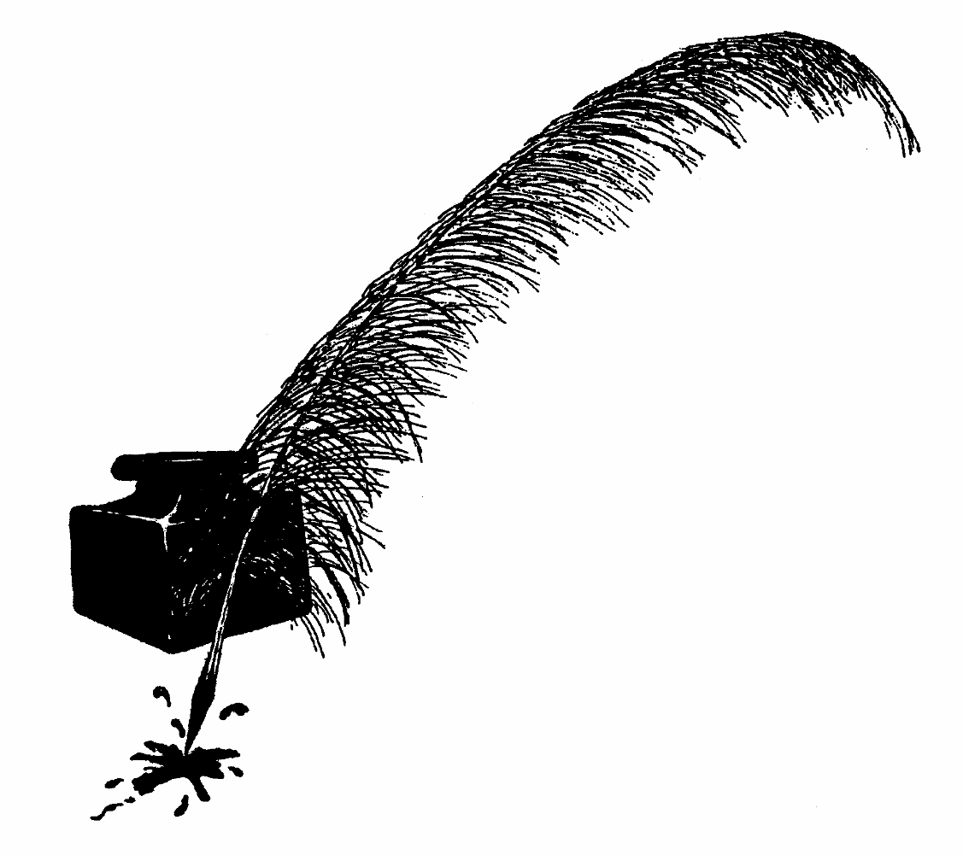
4-H CLUB SECRETARY’S
RECORD BOOK

Club Name

County

Secretary

Club Year


Cooperative Extension Service
College of Agriculture and Home Economics

4-H CLUB MOTTO

To Make the Best Better 4-H CLUB PLEDGE
I pledge my head to clearer thinking My heart to greater loyalty
My hands to larger service and my health to better living
For my club, my community, my country and my world.

New Mexico State University is an equal opportunity/affirmative action employer and educator. NMSU and the U.S. Department of Agriculture cooperating.

Officers
For 20 -

President - Vice President - Secretary - Treasurer - Reporter - Parliamentarian - Song & Recreation Leader -
-

Committees
Name of Committee | Members (List Chairman first)

Name | Telephone Number

Name | Telephone Number

Goals for the Year

Early in the year, list the things that the club members want the club to accomplish. The club members should approve the goals and plan activities to reach them. Plan to report on your progress at the end of the year.

Null

Club Calendar for this Year

Event | Date | Place | Who’s in Charge

What | Who will do it
Call to order
Opening Ceremonies
Roll Call
Minutes of Last Meeting
Correspondence
Officer’s Reports
Committee Reports
Old Business (list)
New Business (list)
Announcements
Adjourn

Minutes for , 20

The
meeting of the

Club was held on , 20 at
, called the meeting to order at o’clock.

Approved:
Date
Secretary (or person who took these minutes)

President

What | Who will do it
Call to order
Opening Ceremonies
Roll Call
Minutes of Last Meeting
Correspondence
Officer’s Reports
Committee Reports
Old Business (list)
New Business (list)
Announcements
Adjourn

Minutes for , 20

The
meeting of the

Club was held on , 20 at
, called the meeting to order at o’clock.

Approved:
Date
Secretary (or person who took these minutes)

President

What | Who will do it
Call to order
Opening Ceremonies
Roll Call
Minutes of Last Meeting
Correspondence
Officer’s Reports
Committee Reports
Old Business (list)
New Business (list)
Announcements
Adjourn

Minutes for , 20

The
meeting of the

Club was held on , 20 at
, called the meeting to order at o’clock.

Approved:
Date
Secretary (or person who took these minutes)

President

What | Who will do it
Call to order
Opening Ceremonies
Roll Call
Minutes of Last Meeting
Correspondence
Officer’s Reports
Committee Reports
Old Business (list)
New Business (list)
Announcements
Adjourn

Minutes for , 20

The
meeting of the

Club was held on , 20 at
, called the meeting to order at o’clock.

Approved:
Date
Secretary (or person who took these minutes)

President

What | Who will do it
Call to order
Opening Ceremonies
Roll Call
Minutes of Last Meeting
Correspondence
Officer’s Reports
Committee Reports
Old Business (list)
New Business (list)
Announcements
Adjourn

Minutes for , 20

The
meeting of the

Club was held on , 20 at
, called the meeting to order at o’clock.

Approved:
Date
Secretary (or person who took these minutes)

President

What | Who will do it
Call to order
Opening Ceremonies
Roll Call
Minutes of Last Meeting
Correspondence
Officer’s Reports
Committee Reports
Old Business (list)
New Business (list)
Announcements
Adjourn

Minutes for , 20

The
meeting of the

Club was held on , 20 at
, called the meeting to order at o’clock.

Approved:
Date
Secretary (or person who took these minutes)

President

What | Who will do it
Call to order
Opening Ceremonies
Roll Call
Minutes of Last Meeting
Correspondence
Officer’s Reports
Committee Reports
Old Business (list)
New Business (list)
Announcements
Adjourn

Minutes for , 20

The
meeting of the

Club was held on , 20 at
, called the meeting to order at o’clock.

Approved:
Date
Secretary (or person who took these minutes)

President

What | Who will do it
Call to order
Opening Ceremonies
Roll Call
Minutes of Last Meeting
Correspondence
Officer’s Reports
Committee Reports
Old Business (list)
New Business (list)
Announcements
Adjourn

Minutes for , 20

The
meeting of the

Club was held on , 20 at
, called the meeting to order at o’clock.

Approved:
Date
Secretary (or person who took these minutes)

President

What | Who will do it
Call to order
Opening Ceremonies
Roll Call
Minutes of Last Meeting
Correspondence
Officer’s Reports
Committee Reports
Old Business (list)
New Business (list)
Announcements
Adjourn

Minutes for , 20

The
meeting of the

Club was held on , 20 at
, called the meeting to order at o’clock.

Approved:
Date
Secretary (or person who took these minutes)

President

What | Who will do it
Call to order
Opening Ceremonies
Roll Call
Minutes of Last Meeting
Correspondence
Officer’s Reports
Committee Reports
Old Business (list)
New Business (list)
Announcements
Adjourn

Minutes for , 20

The
meeting of the

Club was held on , 20 at
, called the meeting to order at o’clock.

Approved:
Date
Secretary (or person who took these minutes)

President

What | Who will do it
Call to order
Opening Ceremonies
Roll Call
Minutes of Last Meeting
Correspondence
Officer’s Reports
Committee Reports
Old Business (list)
New Business (list)
Announcements
Adjourn

Minutes for , 20

The
meeting of the

Club was held on , 20 at
, called the meeting to order at o’clock.

Approved:
Date
Secretary (or person who took these minutes)

President

What | Who will do it
Call to order
Opening Ceremonies
Roll Call
Minutes of Last Meeting
Correspondence
Officer’s Reports
Committee Reports
Old Business (list)
New Business (list)
Announcements
Adjourn

Minutes for , 20

The
meeting of the

Club was held on , 20 at
, called the meeting to order at o’clock.

Null

Approved:
Date
Secretary (or person who took these minutes)

President

